**Web Designer**

**Emmanuel Jay F. Mumar**

**Website Name**

**iNature**

**Objectives**

**This website is designed to:**

* **Provide images people who wants to view nature**
* **Make profit by making the users apply to your subscriptions**

**Audience**

**The prospect visitors of the website are those people who**

* **have an interest in photography**
* **nature lover**
* **want to relax**

**The website will contain**

* **Home page.** The home page has a slider and shows images that are featured.

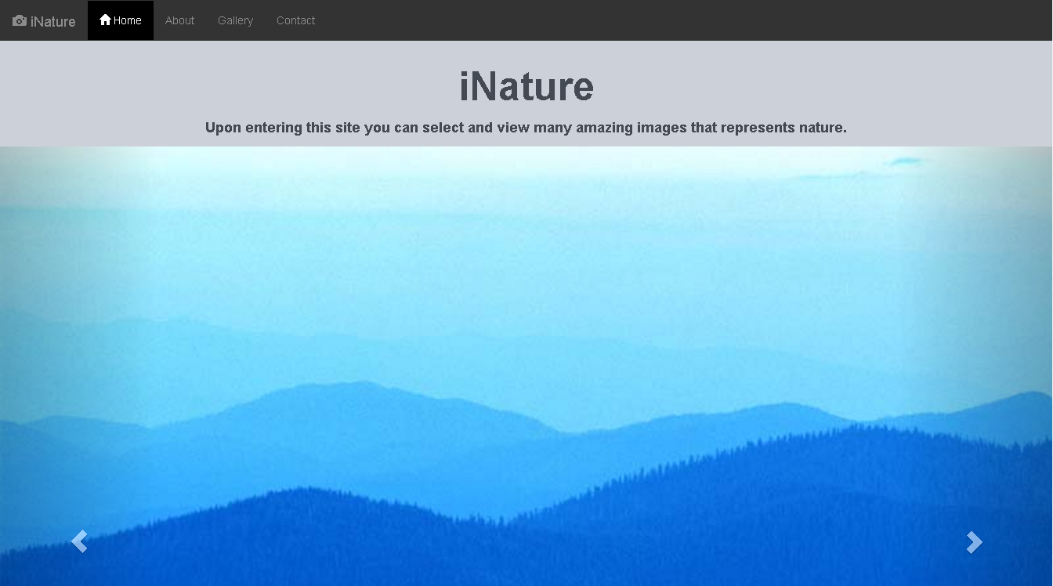

* **About page.** This page contains an iframe that is embedded with a video.

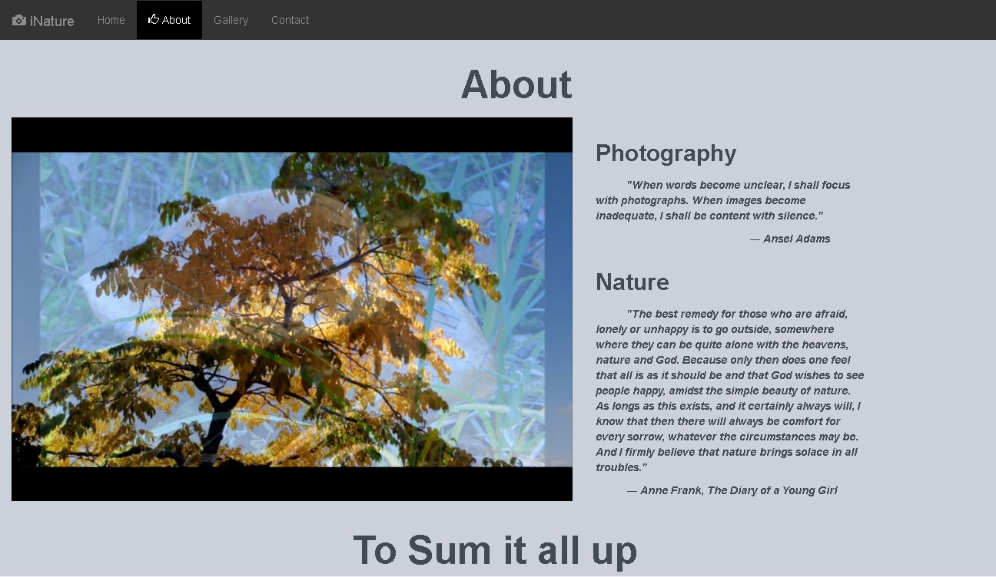

* 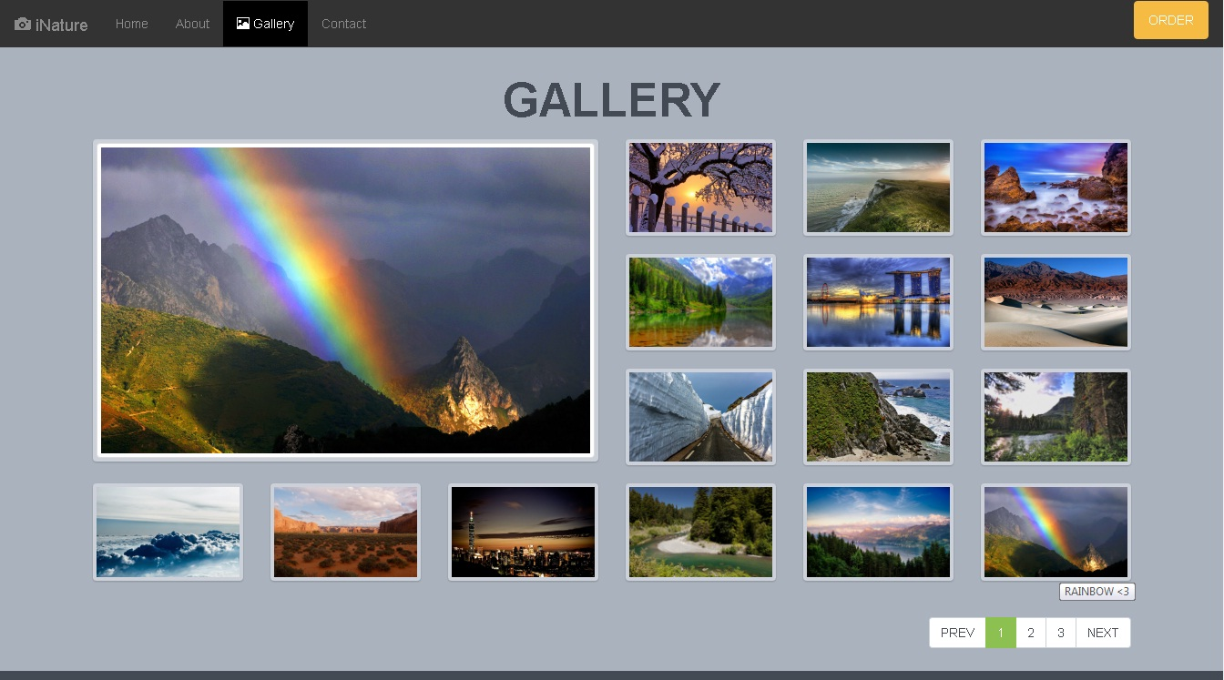**Gallery Page.** In this page a variety of images are shown.
* **Gallery + Modal.** The user selects a subscription in here.

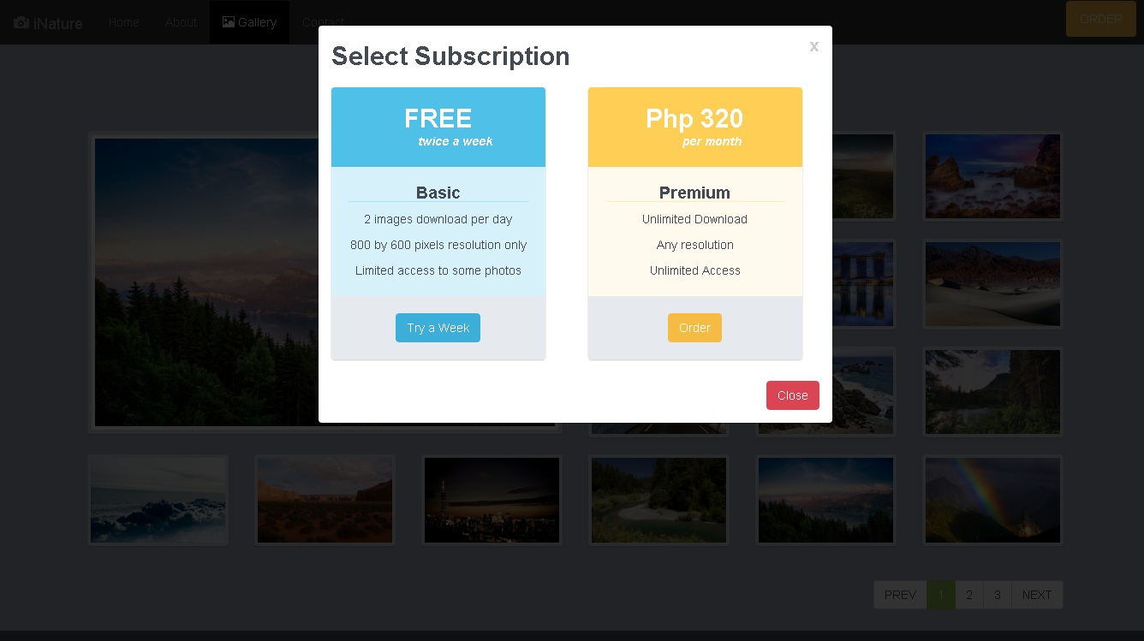

* **Contact.** Inside here the user can contact the developer and send concerns or suggestions.

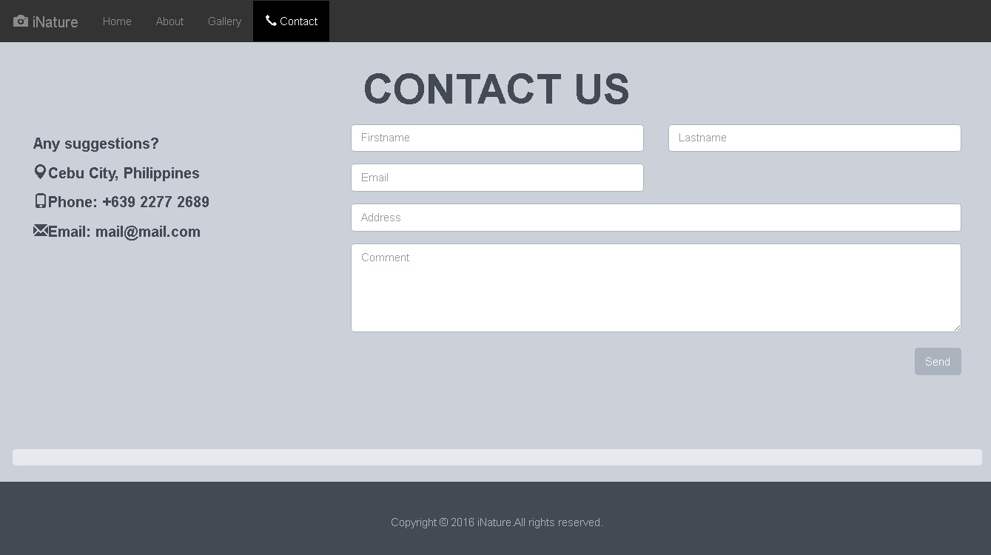

**Features**

* **The gallery provides a gallery viewer in this site a lightbox.**
* **When the user hovers the cursor into an image it is shown in an image container.**
* **Modals are shown to select subscription.**
* **Users can send comments in the contact page.**

**Domain Name**

**www.*inature.pe.hu***